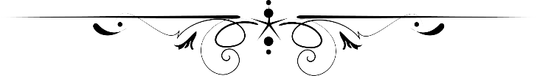

**Assignment**

**Comsats university Islamabad,Lahore Campus**

***Topic :***

**Console of**

**Assignment 3**

Submitted by:

Umair Khalid

Roll no:

SP24-BSE-119

Submitted to

Sir Shahid Bhatti

Date

22 Nov 2024

This is screenshot of output before adding user details

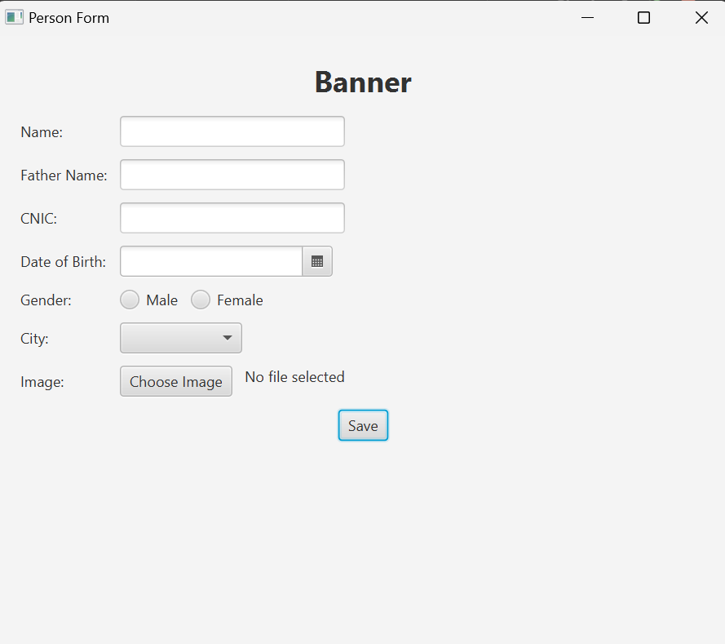

Now see the Alert after adding user details.

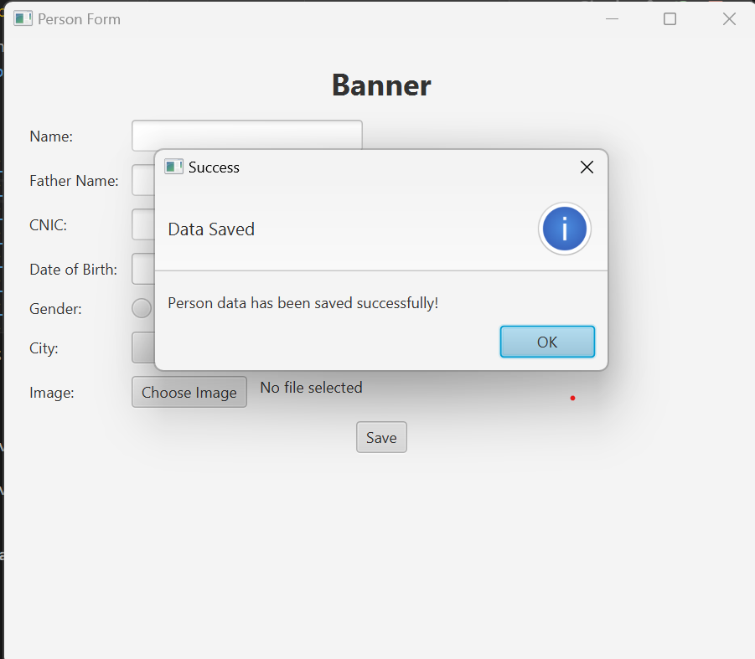

All the details got saved in arraylist of ssperson class